Task 1
Write code and prepare test cases for a function that returns the largest of three real numbers.
The function accepts three numbers as input and returns the largest value among them.
Students should test scenarios such as all three numbers are different, two numbers are equal,Negative numbers etc
Prepare at least 6 test cases that verify the correctness of the function.
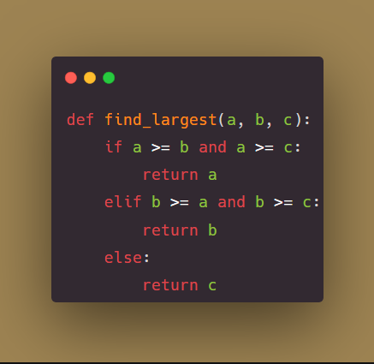
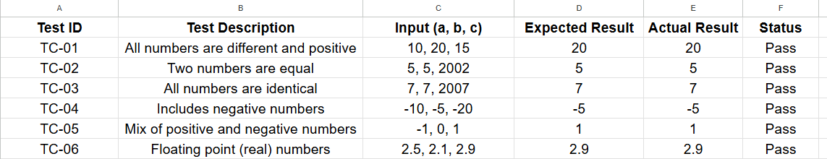

Task 2
Write code and Design test cases for a function that calculates the Least Common Multiple (LCM) of two positive integers.
The function takes two positive integers and returns their least common multiple.
Students should consider cases such as:
- Two different numbers
- Two identical numbers
- Prime numbers
- One number larger than the other
- Edge cases with small values
Prepare at least 6 test cases to verify the correctness of the function.
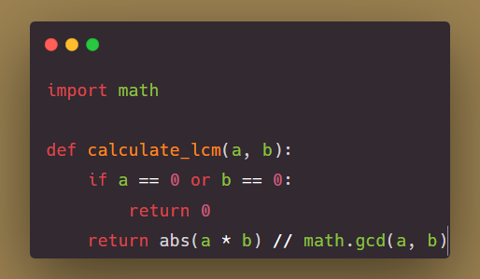
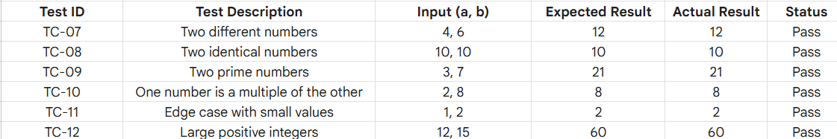

Task 3
Design test cases for a function that calculates the square root of a real number.
The function receives a real number as input and returns its square root.
Students should analyze different situations such as Positive numbers, Invalid inputs etc
Prepare at least 6 test cases for this function.
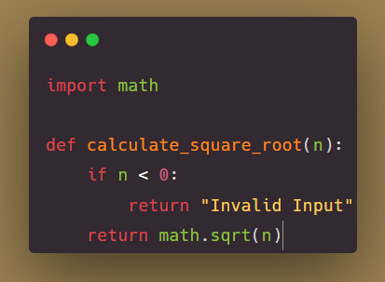
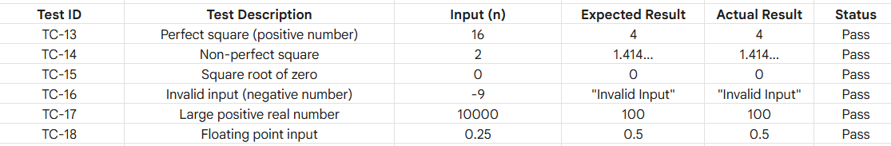

Task 4
Write code and prepare test cases for a function that sorts an array of integers in ascending order.
The function receives:
- An array A
- A variable n, which represents the number of elements in the array
The function returns the array sorted in ascending order.
Prepare at least 6 test cases verifying that the sorting operation works correctly.
